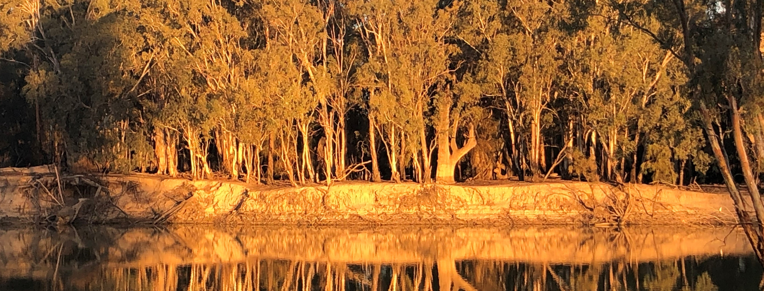

Mallee Community Leadership Group nomination

Community representative nomination form

How to nominate
Any Aboriginal community member over the age of 18 years living within the townships of Mildura, Robinvale, Swan Hill and Kerang may submit a nomination to represent their community on the Mallee Community Leadership Group.
Each nomination must be submitted to the nominated Victorian Government representatives by the closure date and time. Nominations received after this period will be ineligible for consideration.

Send your completed nomination form to:
Mildura and Robinvale nominations: | Swan Hill and Kerang nominations:
Marcus Horwood  Phone: 0428 182 585  Email Marcus Horwood <Marcus.Horwood@dhhs.vic.gov.au> | Mark Williams  Phone: 0457 631 847  Email Mark Williams  <Mark.Williams@dhhs.vic.gov.au>

Application closing date
5.00 pm on 11 September 2020

Nominee details
Information required | Your details
First name:
Surname:
Nominee’s postal address:(include postcode)
Nominee’s phone number:
Nominee’s email address:

Name of township the nominee is representing
Township | Please mark with an X
Mildura
Robinvale
Swan Hill
Kerang

Nominee’s length of connection to community (township represented),
i.e. number of years
Number of years

Are you available to participate in meetings?
Information required | Please mark with an X
Yes
No

Are you employed by the Victorian Government or Mallee District Aboriginal Services?
Information required | Please mark with an X
Yes (if yes complete below)
No
If yes please indicate your employer (This does not exclude you from participating, however conflicts of interest will need to be declared and a process put in place to support your involvement)
Your employer | Please mark with an X
Victoria Government
Mallee District Aboriginal Services

Do you have access to technology to participate in meetings?
(Mobile phone, PC, laptop or iPad)
Information required | Please mark with an X
Yes
No

Are you available to travel within the Mallee area?
(when required and COVID-19 compliant):
Information required | Please mark with an X
Yes
No

Representative criteria
When making your nomination, please provide short statements describing how the nominee meets the following representative criteria. Where possible, provide examples to support the statements.
(Please limit response to space provided)
Information required | Your statement
- Describe the trust and respect your community has in you.
- Describe how you demonstrate cultural integrity.
- Why do you want to represent your community?
- Describe how you approach representing your community.

References
References will need to support your nomination for the Mallee Community Leadership Group.

Referee 1
Information required | Nominee information
Name of referee 1:
Address (include postcode):
Phone number:
Email address:

Referee 2
Information required | Nominee information
Name of referee 2:
Address (include postcode):
Phone number:
Email address:
To receive this form in another format email Marcus Horwood <Marcus.Horwood@dhhs.vic.gov.au> or email Mark Williams <Mark.Williams@dhhs.vic.gov.au>
Authorised and published by the Victorian Government, 1 Treasury Place, Melbourne. © State of Victoria, Australia, September 2020. In this form, ‘Aboriginal’ refers to both Aboriginal and Torres Strait Islander people. Available on the Aboriginal Victoria website <https://www.aboriginalvictoria.vic.gov.au/mallee-community-leadership-group>

